Lab 2

Q1

Q2

Q3

Q4

Q5

Q6

Q7

Q8

Q9

Q10

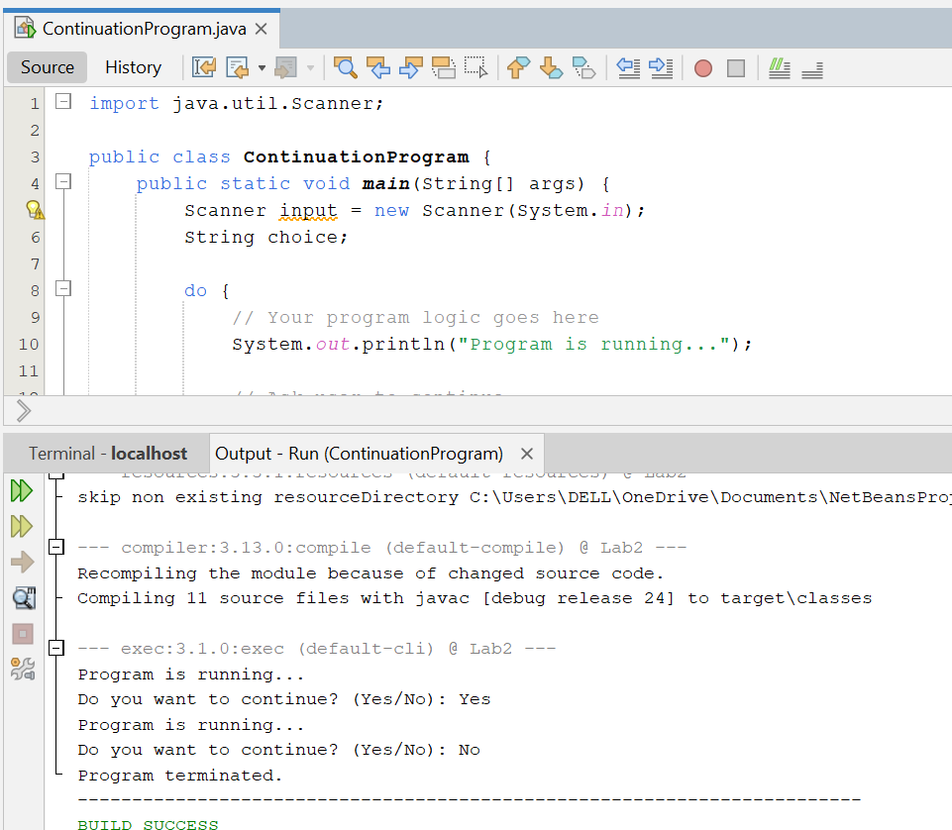

Q11

